Color models

📘 Definition
# Source: AI Source: Provided by: [Data Path: Persons Table -> ID Column: 1, Name_En Column: Motasem Essam] -> From: [ChatGPT] on [5/2/2026]
Color models are systems used to represent colors using numbers or codes so that computers, screens, and printers can create and display colors accurately.

🎨 Common Color Models

1. RGB (Red, Green, Blue)
# Source: AI Source: Provided by: [Data Path: Persons Table -> ID Column: 1, Name_En Column: Motasem Essam] -> From: [ChatGPT] on [5/2/2026]
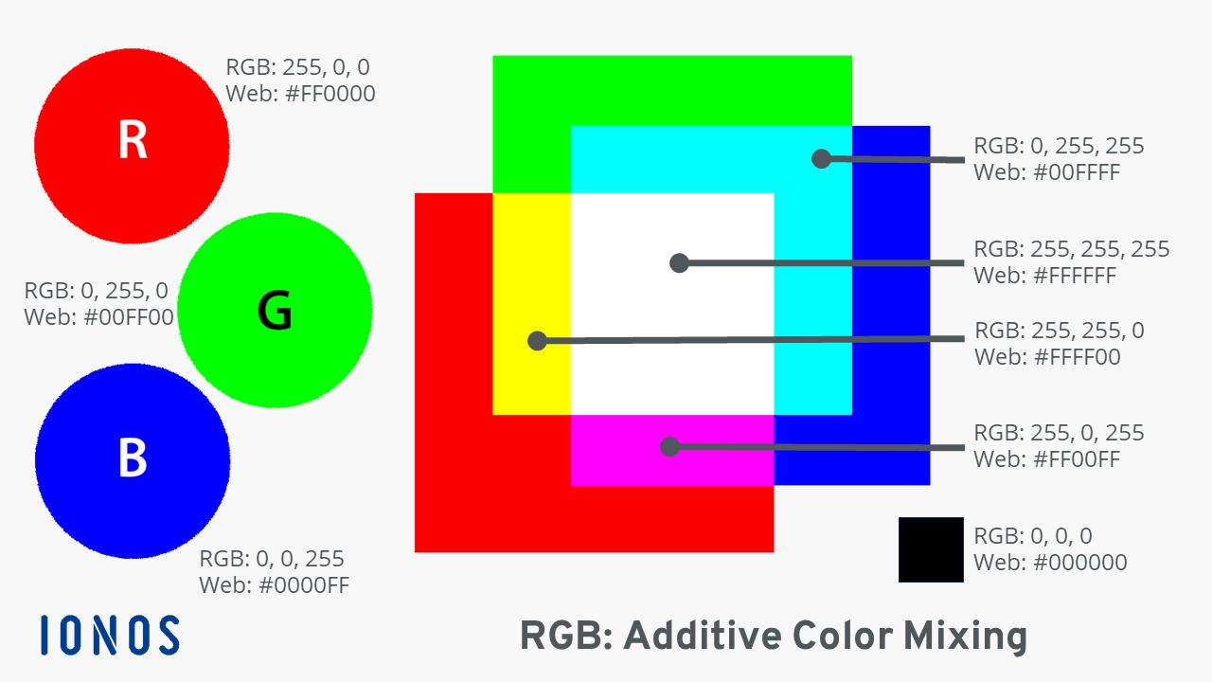
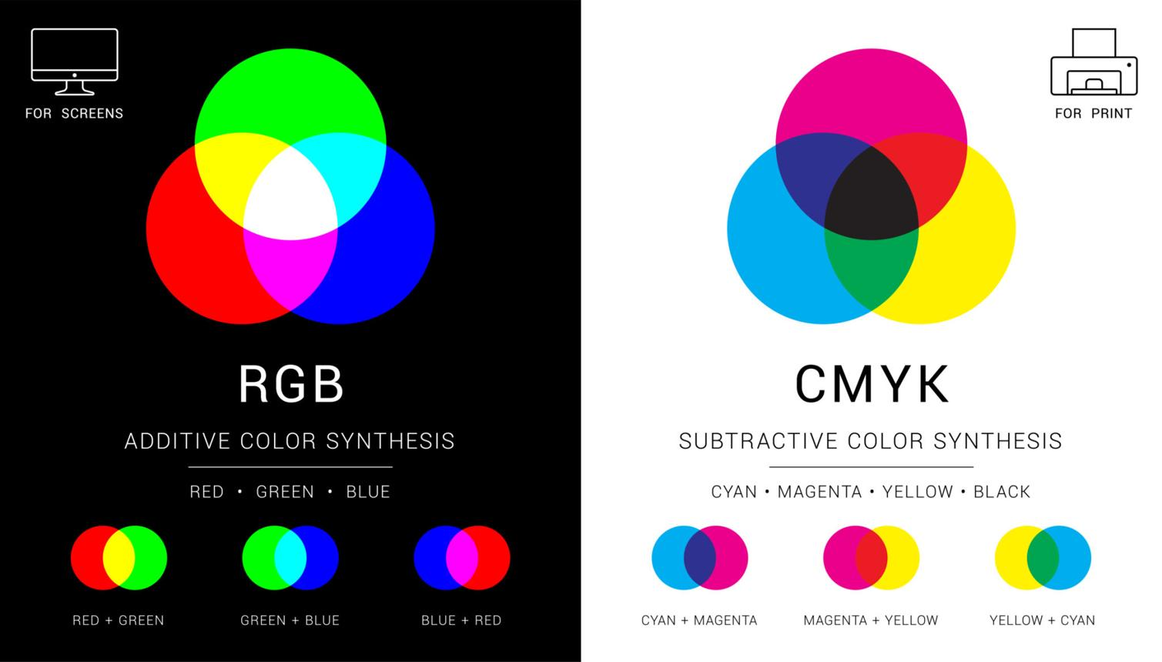
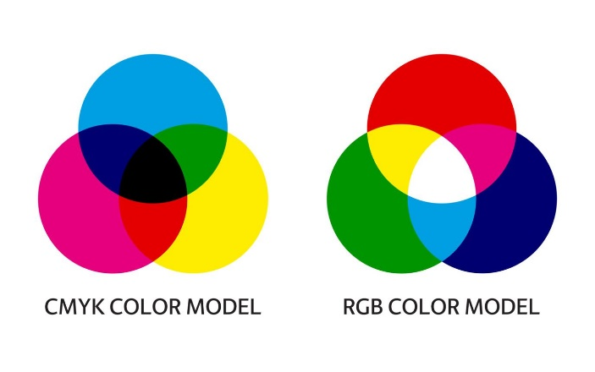
- Used in screens (phones, TVs, computers)
- Colors are created by mixing red, green, and blue light
- Example:
  - Red + Green = Yellow
  - All combined = White

2. RGBA (Red, Green, Blue, Alpha)
# Source: AI Source: Provided by: [Data Path: Persons Table -> ID Column: 1, Name_En Column: Motasem Essam] -> From: [ChatGPT] on [5/2/2026]
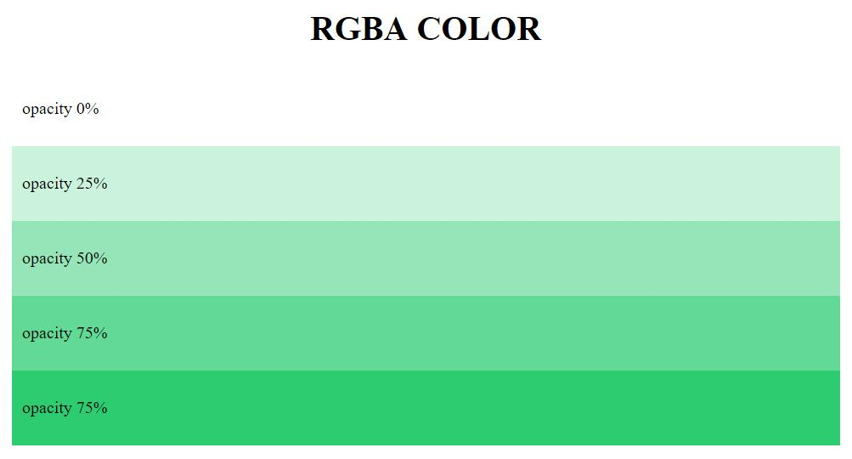
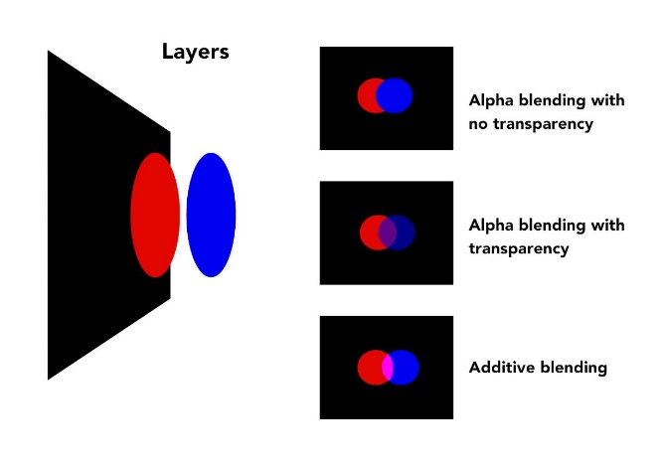
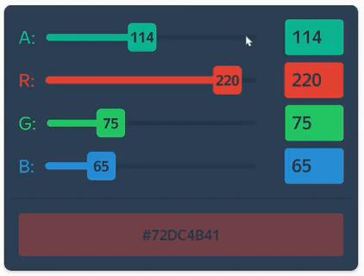
- Used in web design, apps, and graphics software
- Same as RGB but adds Alpha (A)
- Alpha controls transparency (how see-through a color is)
Example:
- rgba(255, 0, 0, 1) → solid red (fully visible)
- rgba(255, 0, 0, 0.5) → semi-transparent red
- rgba(255, 0, 0, 0) → fully transparent (invisible)

3. CMYK (Cyan, Magenta, Yellow, Black)
# Source: AI Source: Provided by: [Data Path: Persons Table -> ID Column: 1, Name_En Column: Motasem Essam] -> From: [ChatGPT] on [5/2/2026]
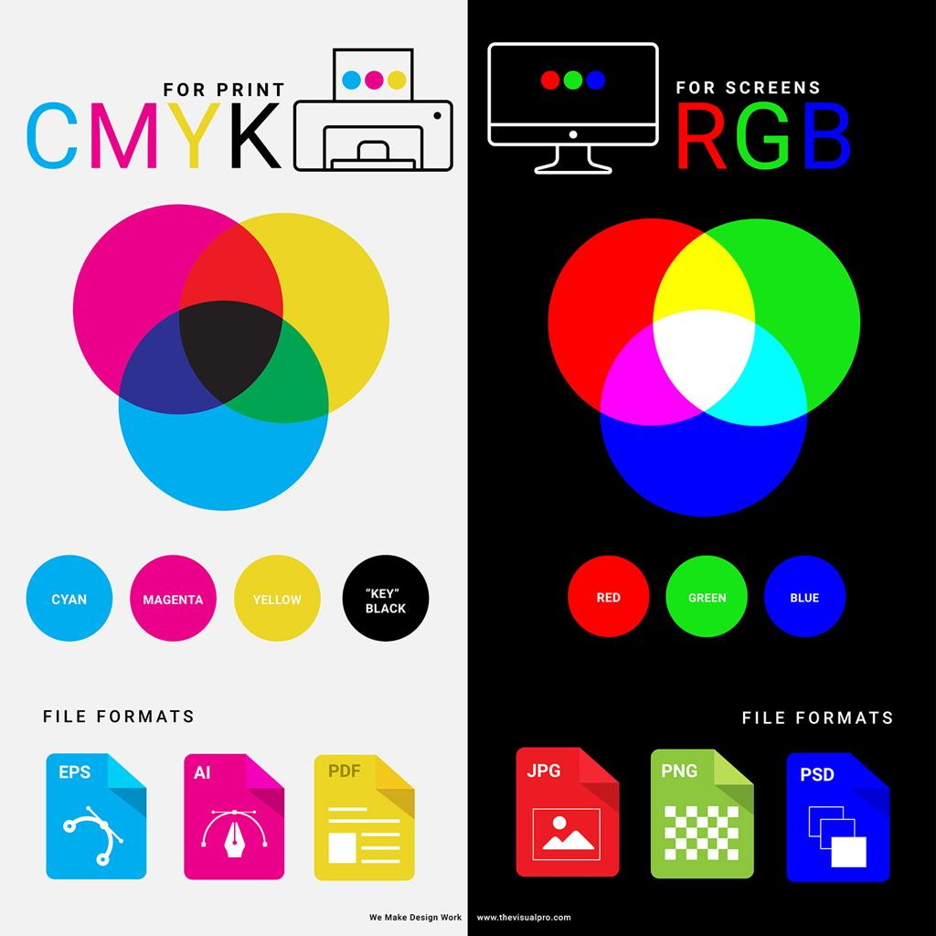

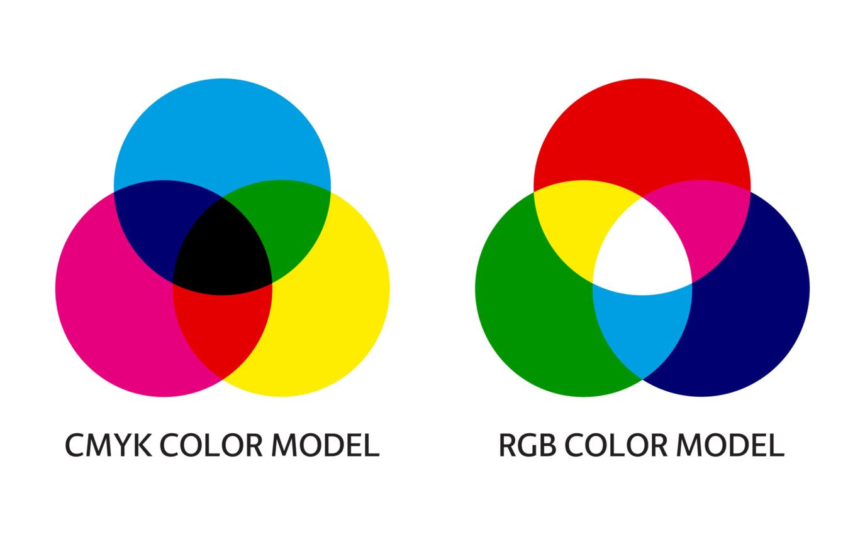
- Used in printing
- Uses ink instead of light
- Colors are layered to create different shades

4. HSV / HSL (Hue, Saturation, Value/Lightness)
# Source: AI Source: Provided by: [Data Path: Persons Table -> ID Column: 1, Name_En Column: Motasem Essam] -> From: [ChatGPT] on [5/2/2026]
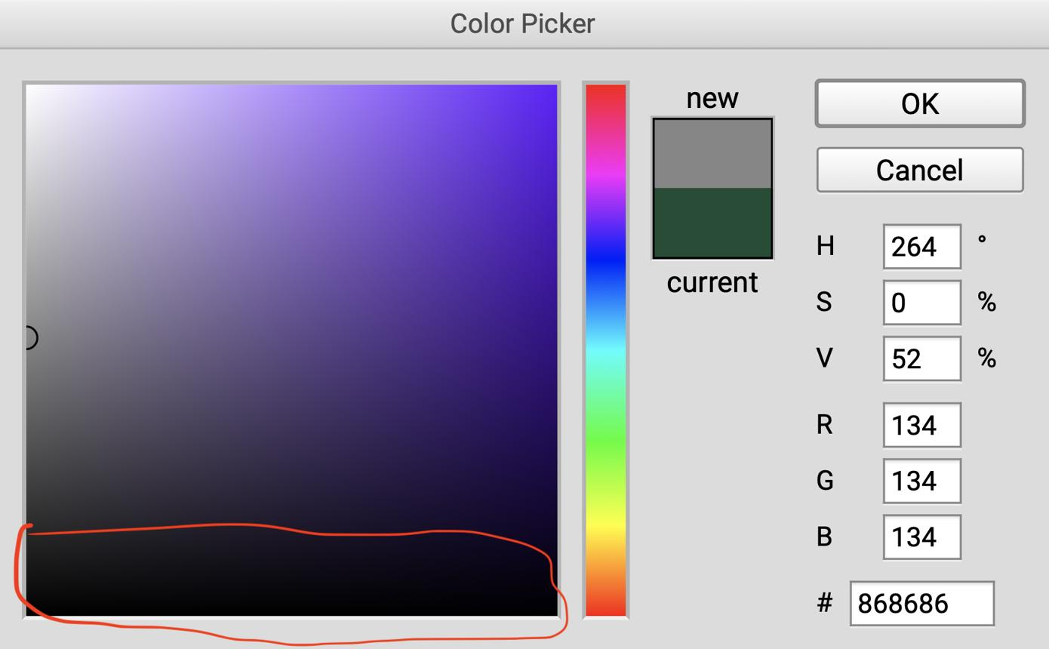
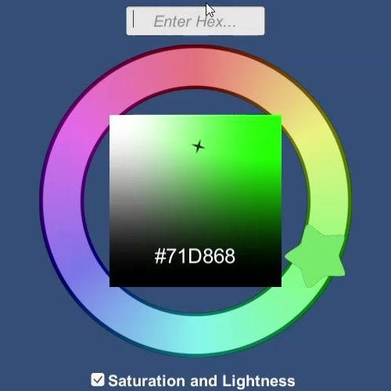
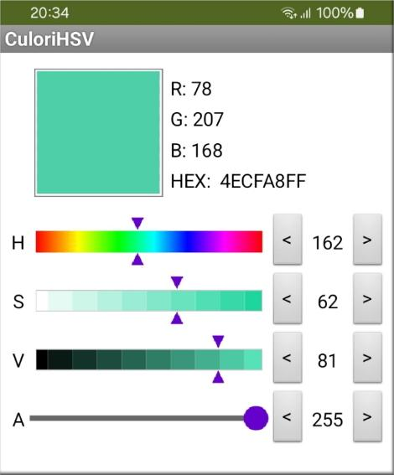
- Used in design tools and image editing
- Describes color in a human-friendly way:
  - Hue → the color type (red, blue, etc.)
  - Saturation → intensity of the color
  - Value/Lightness → brightness or darkness

5. HEX (Hexadecimal Color Code)
# Source: AI Source: Provided by: [Data Path: Persons Table -> ID Column: 1, Name_En Column: Motasem Essam] -> From: [ChatGPT] on [5/2/2026]
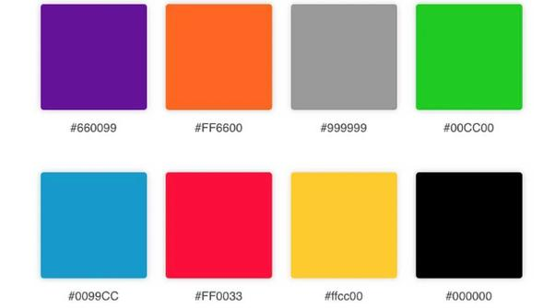
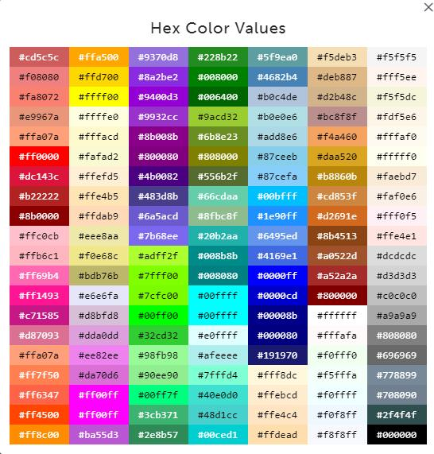
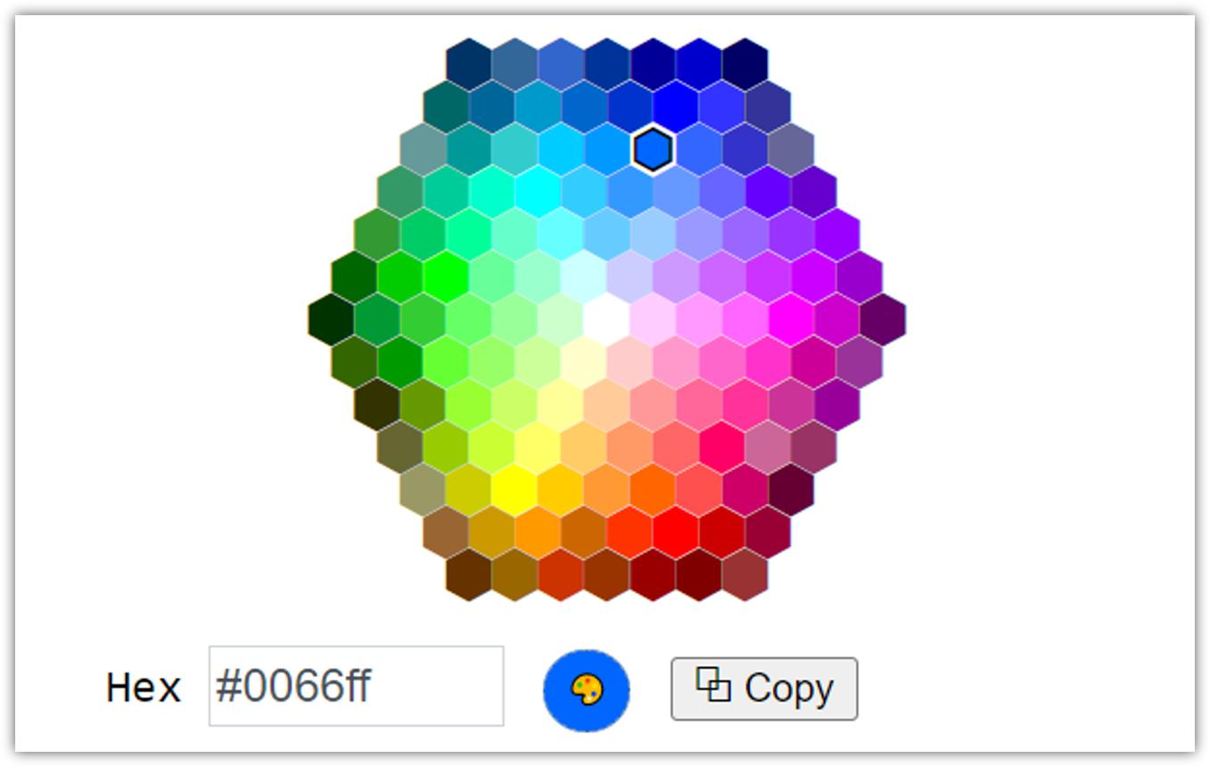
- Used in web design (HTML/CSS)
- Colors are written as a 6-digit code
- Example:
  - #FF0000 = Red
  - #00FF00 = Green
  - #000000 = Black
Each pair of digits represents red, green, and blue values in hexadecimal form.

🧠 Why color models are important
# Source: AI Source: Provided by: [Data Path: Persons Table -> ID Column: 1, Name_En Column: Motasem Essam] -> From: [ChatGPT] on [5/2/2026]
They help:
- Computers display accurate colors
- Designers control and match colors easily
- Printers reproduce colors correctly
- Websites and apps look consistent

🚀 In short:
# Source: AI Source: Provided by: [Data Path: Persons Table -> ID Column: 1, Name_En Column: Motasem Essam] -> From: [ChatGPT] on [5/2/2026]
Color models = different systems (RGB, CMYK, HSV, HEX) used to describe and create colors in digital and print media.

